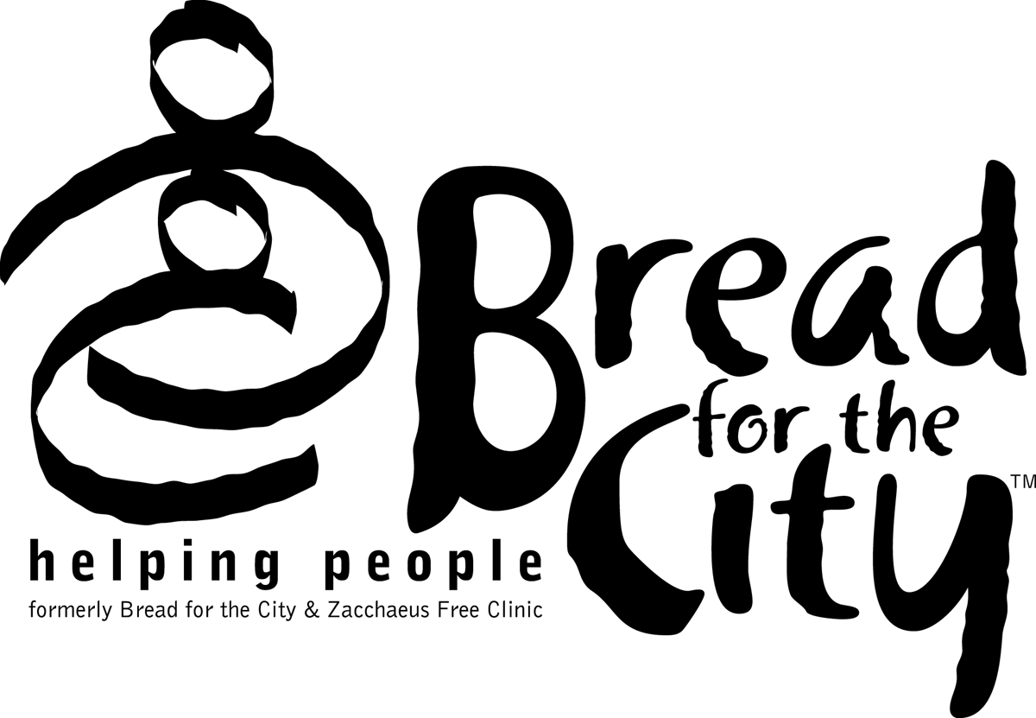
Bread for the City
Representative Payee Program

Next of Kin

The Bread for the City Representative Payee Program will use the information provided below in the event of the consumer’s death to administer any funds remaining in his/her account.

Consumer Name: |  |  |  |  |  |  |  |  |  |  |  |  |  |  |  |  |  |  | SSN:
Do you have a will? |  |  |  |  |  | □ YES □ NO
If you have a will, we suggest that you inform the Next of Kin listed below about how they can find a copy of your will in the event of your passing.
Next of Kin – Primary Contact:
Name: |  |  |  |  |  |  |  |  |  |  |  | Relationship:
Address:
Home Phone: |  |  |  |  |  |  |  |  |  | Work Phone: |  |  |  |  |  |  |  |  |  | Other Phone:
Next of Kin – Secondary Contact: (to be used if we are unable to reach your primary contact)
Name: |  |  |  |  |  |  |  |  |  |  |  | Relationship:
Address:
Home Phone: |  |  |  |  |  |  |  |  |  | Work Phone: |  |  |  |  |  |  |  |  |  | Other Phone:
□ I have no Next of Kin |  |  |  |  |  |  |  |  |  |  | If checked please initial here.
Consumer’s Signature: |  |  |  |  |  |  |  |  |  |  |  |  |  |  |  |  |  |  |  |  | Date:
Please inform Bread for the City of any changes to the information provided here, including any changes to the contact information for your Next of Kin. Bread for the City will ask you to review this information annually to make sure that we are aware of any changes.

