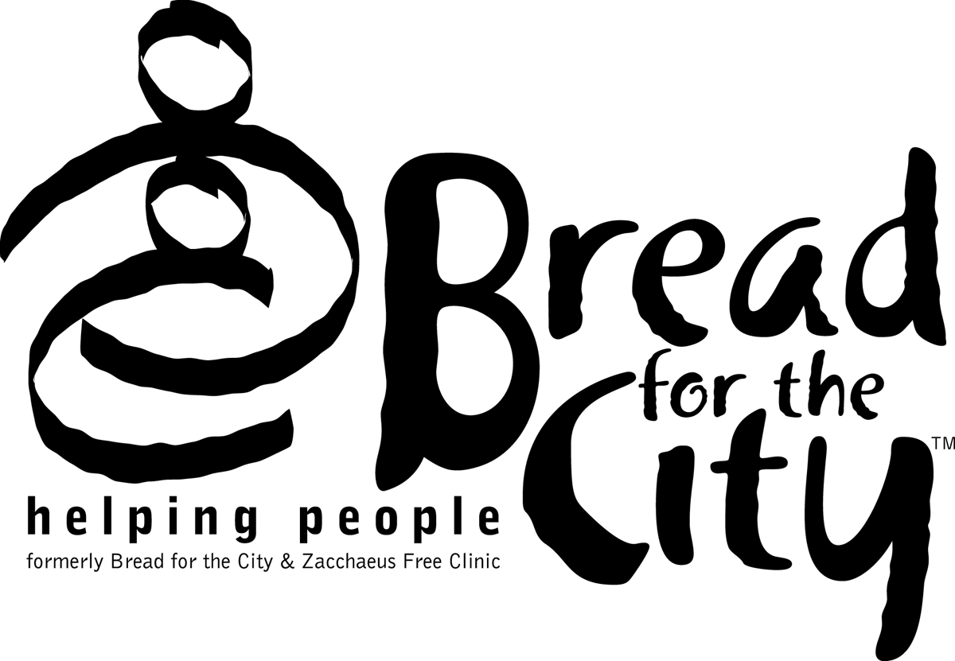
Bread for the City
Representative Payee Program

Next of Kin
Information from CSW

Use this form if the Bread for the City Representative Payee Program consumer named below is unwilling or unable to provide the information requested on the standard Next of Kin reporting form. This form is to be completed by a member of the Clinical Team and signed by that member and by the Clinical Supervisor. Bread for the City will use the information provided below to attempt to contact the consumer’s Next of Kin at the time of the consumer’s death if any funds remain in the consumer’s account.

Consumer Name: |  |  |  |  |  |  |  |  |  |  |  |  |  |  |  |  |  | SSN:
Does the consumer have a will? |  |  |  |  |  |  |  | □ YES □ NO □ UNKNOWN
Next of Kin – Primary Contact:
Name: |  |  |  |  |  |  |  |  |  | Relationship:
Address:
Home Phone: |  |  |  |  |  |  | Work Phone: |  |  |  |  |  |  |  |  |  | Other Phone:
Next of Kin – Secondary Contact: (to be used if we are unable to reach the primary contact)
Name: |  |  |  |  |  |  |  |  |  | Relationship:
Address:
Home Phone: |  |  |  |  |  |  | Work Phone: |  |  |  |  |  |  |  |  |  | Other Phone:
□ We are not aware of any Next of Kin for the above named consumer
Signature, Clinical Team Member: |  |  |  |  |  |  |  |  |  |  |  |  |  |  |  |  |  |  | Date:
Signature, Clinical Supervisor: |  |  |  |  |  |  |  |  |  |  |  |  |  |  |  |  |  |  | Date:
Please update this form if you become aware of any changes to the information provided here, including the contact information for the Next of Kin. This information should be reviewed annually to make sure that Bread for the City has record of any changes.

